## 

## 

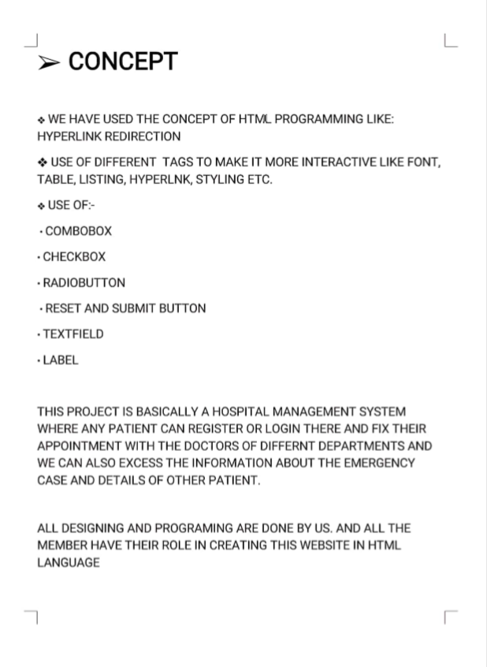

## **HOSPITAL MANAGEMENT SYSTEM**

## **SECTION K19HZ**

## **GROUP MEMBERS:**

## **ANOOP KUMAR ROLL NO.->65**

## **ASHISH KUMAR ROLL NO.->63**

## **GUDDU KUMAR——ROLL NO,->64**

## **SUBMITTED TO: MRS. MANU BALI**

## **WORK DIVISION**

OUR TEAM MEMBERS ARE:-

* ANOOP KUMAR
* GUDDU KUMAR
* ASHISH KUMAR

*ANOOP KUMAR:- IS INCHARGE OF CREATING LAYOUTAND DESIGNING THE WEBSITE AS WELL AS ADDING CSS AND ETC.

*ASHISH KUMAR:- WORKED REGARDING FORM IN APOINTMENT PAGE AND OTHER SPACES.HE ALSO WORKED ON THE DESIGN AND LAYOUT WITH ANOOP KUMAR.

*GUDDU KUMAR:- IS DOING THE CSS STUFF AND WRITING THE REPORT AND ALSO IMPLEMENTING ADD TO LIBRARY.

## **INTRODUCTION OF HOSPITAL MANAGEMENT WEBSITE**

## **IN THIS PROJECT WE ARE GOING TO CREATE A HOSPITAL MANAGEMENT SYSTEM SITE USING HTML.**

## **WE HAVE PLANNED AND GOING TO CREATE AS PER THE DESIGN GIVEN BY THE INSTRUCTOR.**

## **WHICH INCLUDE:**

## **HOME PAGE WHICH WILL PROVIDE ALL THE NESSESARY VIEW**

## **LOGIN AND SIGN UP LINK WHICH WILL REDIRECT USER TO NEW TAB TO LOGIN PAGE**

## **ABOUT US WHICH WILL GIVE THE DETAIL OF THE SITE OWNER AND CONTACT DETAILS.**

## **DIFFERENT TAB FOR MORE FUNCTIONS LIKE:-**

## **DEPARTMENT WHICH PROVIDE TYPES OF DEP. IN HOSPITAL**

## **EMERGENCY WHICH PROVIDE BURN AND ACCIDENT CASE REGISTER IN THE HOSPITAL**

## **BOOK APPOINTMENT PROVIDE THE EXCESS TO APOINT A MEETING WITH DOCTOR**

## **DOCTORS PROVIDE US THE DETAILS ABOUT THE DOCTORS OF DIFFERENT DEPARTMENT**

## **MY ACCOUNT WILL SHOW THE PROFILE OF THE PATIENT WHO HAVE SIGNED IN.**

## 

## 

## **TAGS AND ATTRITBUTES WE USED :**

IN THIS WEBSITE WE USE :

* EXTERNAL CSS: FOR DECORATION OF WEBSITE TO MAKE THE WEBSITE MORE ATTRACTIVE.
* LINK TAG: FOR MAKE THE CONNECTION BETWEEN THE OTHER PAGES.
* IMAGE TAGS: FOR INSERTION OF THE IMAGE IN OUR WEBSITE
* TABLE TAGS: FOR THE FORMATION OF TABLE IN THE WEBSITE.
* HTML HEX COLORS: A COLOR CAN BE SPECIFIED USING A HEXADECIMAL VALUE .
* AND USE OTHER COMMON TAGS AND ATTRITBUTES FOR INTERNAL AND EXTERNAL CSS AND SHOW OUR CONTENT AND WEBSITE IN PROPER WAYS .

## **WHAT IS A HOSPITAL MANAGEMENT SOFTWARE ?**

As long as each stage implementation needs to be accurate and explicit, the clinic management system provides certain [automation](https://www.medicaldevice-network.com/features/expert-views-benefits-automation-healthcare-industry/) of many vital daily processes. The hospital system software covers the services that unify and simplify the work of healthcare professionals as well as their interactions with patients.

There is always the wide choice of features that can be included in the system. Moreover, the most important thing they are created to streamline various procedures that meet the needs of all the users. The hospital management system feature list is concentrated on providing the smooth experience of patients, staff and hospital authorities. It might seem that their expectations differ, they still are covered by components of the hospital information system. Quality and security still remain the main criteria of the medical industry. It is also known for the constant and rapid changes to improve the efficiency of medical services and satisfaction of the patients.

Hospital management has greatly changed over the last decades. Business expertise, modern technologies, [connected devices](https://existek.com/embedded-software-outsourcing-company-development-services/), mobile apps, and knowledge of healthcare are key elements for the implementation of hospital management system project. The number of healthcare providers has increased and the patients have a wide choice of medical specialists. The interactions between the hospital and the patient can be simplified for the convenience of both sides. Each institution has the opportunity to create the efficient, clear and fast delivering.

Depending on the hospital management system software features, it can deal with a lot of tasks. It helps to outline and implement policies, guarantee communication and coordination between employees, automate routine tasks, design the patient-oriented workflows, advertise services, manage human and financial resources and provide the uninterrupted supply chain. The components of a hospital information system can be chosen and combined in the general system that meets the needs and norms of the healthcare industry as well as quality standards. One of the main requirements of the clinic management system is security. All medical records have to be protected and only accessible for the allowed users. The convenient and informative interfaces should correspond to their roles and responsibilities in order to protect the confidential data.

Since the purpose of the hospital information system is the arrangement of necessary, precise and appropriate data, the hospitals should ensure the system work and can be accessed at any time. The online hospital management system and desktop (on premise) solutions are possible options of the healthcare providers. This could be a unique system for the certain institution, chain of clinics, state hospitals or even the international medical organizations. It is usually started with the basic version that can be scaled up.

HOSPITAL MANAGEMENT

SYSTEM ADVANTAGES

### **Improved Processes**

Automation is one of the main benefits here. It helps to optimize the user experience. Medical specialists, patients, and hospital authorities can interact online, make the appointments and exchange information.

### **Digital medical records**

The hospital database includes all the necessary patient data. The disease history, test results, prescribed treatment can be accessed by doctors without much delay in order to make an accurate diagnosis and monitor the patient’s health. It enables lower risks of mistakes.

### **Staff interaction**

It is vital to engage all of your employees for improved coordination and teamwork. They do not need to make special requests and wait for a long time for an answer. Each specialist will be in charge of certain process stage and can share outcomes with colleagues just in one click.

### **Facility management**

Hospitals authorities are able to manage their available resources, analyse staff work, reduce the equipment downtime, optimize the supply chain, etc. Another fact to mention is that hospital staff deal with the digital data instead of endless paperwork.

### **Financial control and tax planning**

The management has the ability to monitor different financial operations including expenses, profits, and losses, paying bills and taxes, in and outpatient billing. The financial awareness helps to analyse business prospects quite clear and move in the right direction.

### **Market strategy**

Due to the high market competitive nature, the medical industry is also open to all the different innovations that enable communication between patients, doctors, suppliers, and marketing services providers.

### **Insurance claims processing**

Integration with health insurance services improves the experience of the patients and brings benefits to the institution. It allows you to be innovative and helps both the patient and hospital to handle many aspects of the insurance process successfully.

### **Less time consuming**

As the services and interactions are improved in all possible ways, everything is being planned with greater precision. It saves the time of all the system users and provides them with up-to-date information.

### **Patient self-service**

Patients have their own system accounts where the list of various actions can be performed. They are able to make online requests or reservation, receive the test results, receive the consultation of the medical specialists and many more.

### **Better customer experience**

Since the clinic management system is patient-oriented, the treatment process can be less stressful. Doctors have more time for the examination and interaction with patients. In addition, all the requested information can be received online.